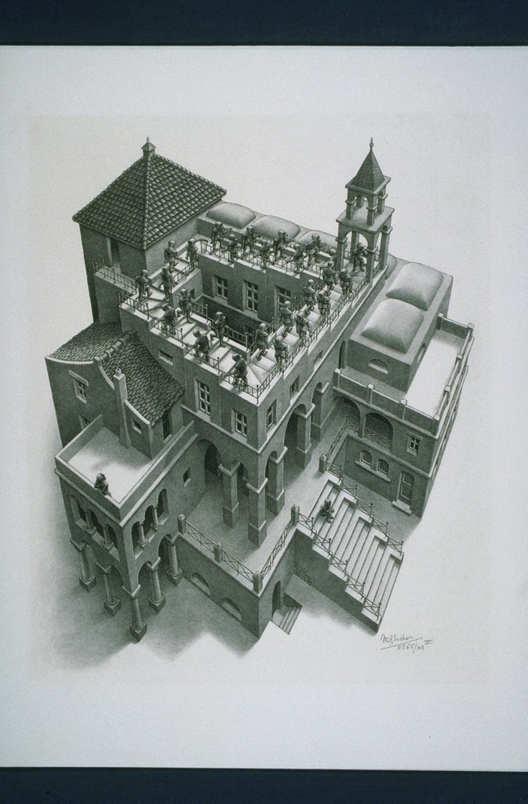

Fig 1. Maurits Cornelis Escher, *Ascending Descending*, 1960, Lithograph, 35.5 cm × 28.5 cm, Davis Museum and Cultural Center, Wellesley College, <https://library.artstor.org/#/asset/AMICO_DAVIS_103814594>